**ASSIGNMENT 3**

1. **PROBLEM STATEMENT :**

Programming of the project functions, interfaces and GUI (if any) as per 1 st Term term-work submission using corrective actions recommended in Term-I assessment of Term-work.

1. **THEORY:**

**2.1 GRAPHICAL USER INTERFACE DESIGN :**

**2.1.1 HTML :**

Hypertext Markup Language (HTML) is the standard markup language for creating web pages and web applications. With Cascading Style Sheets (CSS) and JavaScript it forms a triad of cornerstone technologies for the World Wide Web. Web browsers receive HTML documents from a webserver or from local storage and render them into multimedia web pages. HTML describes the structure of a web page semantically and originally included cues for the appearance of the document.

HTML elements are the building blocks of HTML pages. With HTML constructs, images and other objects, such as interactive forms, may be embedded into the rendered page. It provides a means to create structured documents by denoting structural semantics for text such as headings, paragraphs, lists, links, quotes and other items. HTML elements are delineated by *tags*, written using angle brackets. Tags such as <img /> and <input /> introduce content into the page directly. Others such as <p>...</p> surround and provide information about document text and may include other tags as sub elements. Browsers do not display the HTML tags, but use them to interpret the content of the page.

**2.1.2 .CSS :**

Cascading Style Sheets (CSS) is a style sheet language used for describing the presentation of a document written in a markup language. Although most often used to set the visual style of web pages and user interfaces written in HTML and XHTML, the language can be applied to any XML document, including plain XML, SVG and XUL, and is applicable to rendering in speech, or on other media. Along with HTML and JavaScript, CSS is a cornerstone technology used by most websites to create visually engaging webpages, user interfaces for web applications, and user interfaces for many mobile applications.

CSS is designed primarily to enable the separation of document content from document presentation, including aspects such as the layout, colors, and fonts. This separation can improve content accessibility, provide more flexibility and control in the specification of presentation characteristics, enable multiple HTML pages to share formatting by specifying the relevant CSS in a separate .css file, and reduce complexity and repetition in the structural content.

**2.2 PROJECT FUNCTION IMPLEMENTATION :**

**2.2.1 JSP(Java Server Pages ):**

**JavaServer Pages** (**JSP**) is a technology that helps software developers create dynamically generated web pages based on HTML, XML, or other document types. Released in 1999 by Sun Microsystems, JSP is similar to PHP,

ASP and React's JSX but it uses the Java programming language.To deploy and run JavaServer Pages, a compatible web server with a servlet container, such as Apache Tomcat or Jetty, is required.

Architecturally, JSP may be viewed as a high-level abstraction of Java servlets. JSPs are translated into servlets at runtime,therefore JSP is a Servlet; each JSP servlet is cached and re-used until the original JSP is modified. JSP can be used independently or as the view component of a server-side model–view–controller design, normally with JavaBeans as the model and Java servlets (or a framework such as Apache Struts) as the controller. This is a type of Model 2 architecture.JSP allows Java code and certain predefined actions to be interleaved with static web markup content, such as HTML, with the resulting page being compiled and executed on the server to deliver a document. The compiled pages, as well as any dependent Java libraries, contain Java bytecode rather than machine code. Like any other Java program, they must be executed within a Java virtual machine (JVM) that interacts with the server's host operating system to provide an abstract, platform-neutral environment.

**2.2.2 Servlet :**

A **Java servlet** is a Java program that extends the capabilities of a server. Although servlets can respond to any types of requests, they most commonly implement applications hosted on Web servers.The Servlet API, contained in the Java package hierarchy javax.servlet, defines the expected interactions of the web container and a servlet.

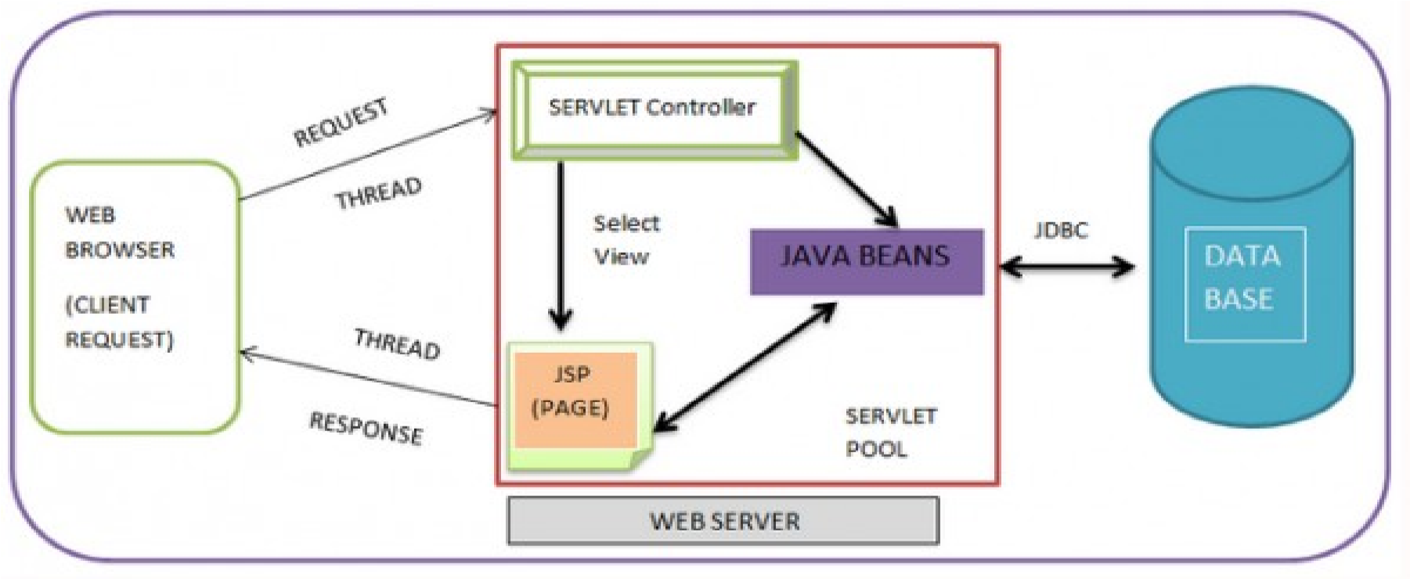

A Servlet is an object that receives a request and generates a response based on that request. The basic Servlet package defines Java objects to represent servlet requests and responses, as well as objects to reflect the servlet's configuration parameters and execution environment. The package javax.servlet.http defines HTTP-specific subclasses of the generic servlet elements, including session management objects that track multiple requests and responses between the web server and a client. Servlets may be packaged in a WAR file as a web application.

**2.2.3 Apache Tomcat:**

Apache Tomcat, often referred to as Tomcat Server, is an open-source Java Servlet Container developed by the Apache Software Foundation (ASF). Tomcat implements several Java EE specifications including Java Servlet, JavaServer Pages (JSP), Java EL, and WebSocket, and provides a "pure Java" HTTP web server environment in which Java code can run. Tomcat is developed and maintained by an open community of developers under the auspices of the Apache Software Foundation, released under the Apache License 2.0 license, and is open-source software.

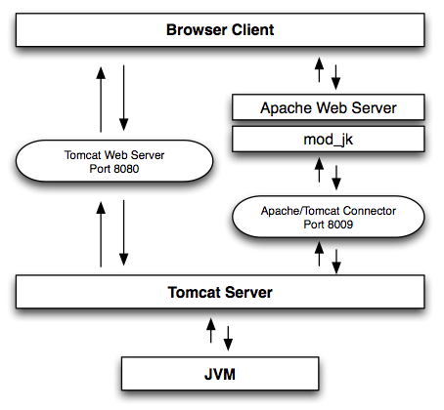

**CONCLUSION:-**

Hence we programmed project functions, interfaces and GUI as per first term term work.